Review List for Final Resurfacing Projects
WBS #: | Click or tap to edit.
County: | Click or tap to edit.
Division: | Click or tap to edit.
Letting Date: | Click or tap to edit.
Review List for Final Resurfacing Plans (2024 Standard Specifications)
Item # | Review Item | Yes | No | N/A
 | Resurfacing File Naming Convention
1 | Maps, Typical Sections, Details, Summary of Quantities:  Prefix: 001_###_WBS ELEMENT_FILE NAME.PDF  ### = File Number Sequence (use a number sequence of 3 (i.e., 003, 006, etc.)  FILE NAME = MAP#, TYP#, DET NAME/#, SOQ, etc.  (example 001_003_2026 CPT.05.03.10921.1, etc._MAP1.PDF, 001_006_2026 CPT.05.03.10921.1, etc._MAP2.PDF, etc.) | ☐ | ☐ | ☐
2 | Traffic Control:  Prefix 002_###_WBS ELEMENT_TMP#.PDF | ☐ | ☐ | ☐
3 | Erosion Control:  Prefix 003_###_WBS ELEMENT_EC#.PDF | ☐ | ☐ | ☐
4 | Traffic Signals:  Prefix 004_###_WBS ELEMENT_SIG#.PDF | ☐ | ☐ | ☐
5 | The order of the resurfacing package plans is as follows: maps, typical sections, special details, summary of quantity sheets, traffic control, erosion control, and traffic signals. Number the maps, typical sections, special details, and summary of quantity sheets in ascending order starting with sheet 1. Traffic Control plans should be numbered as TMP1, TMP2, etc. Erosion Control plans as EC1, EC2, etc. Traffic Signal plans as SIG1, SIG2, etc. | ☐ | ☐ | ☐
 |  | ☐ | ☐ | ☐
 | Maps
1 | Does each section description agree with the map limits? | ☐ | ☐ | ☐
2 | Are the route numbers correct on the maps? | ☐ | ☐ | ☐
3 | Do the route numbers on the maps correspond with the map description on the summary of quantities? | ☐ | ☐ | ☐
4 | Is the mileage for each section shown correctly? | ☐ | ☐ | ☐
5 | Do the maps have north arrows, county names, WBS numbers, and TIP number (if applicable)? If you have more than two WBS numbers, you may list the first one followed by “etc.” Show the WBS numbers in the title block in the upper right-hand corner. WBS elements should be in numerical order beginning with the smallest number. | ☐ | ☐ | ☐
6 | Use a NCDOT Roadway title sheet if the resurfacing project has a TIP number. | ☐ | ☐ | ☐
 |  | ☐ | ☐ | ☐
 | Typical Sections
1 | Do the typical sections represent the intended construction? (i.e., are existing ditches being moved, shoulders added, etc.?) | ☐ | ☐ | ☐
2 | Does the proposed resurfacing pavement width of each section/map agree with the typical sections? | ☐ | ☐ | ☐
3 | Does the pavement schedule show the correct material types and application rates? | ☐ | ☐ | ☐
4 | Add the pavement schedule to each typical section sheet. | ☐ | ☐ | ☐
5 | If there is shoulder construction, show a shoulder width on the typical section. | ☐ | ☐ | ☐
6 | If there is milling, typical sections should indicate this. If milling does not apply to all maps referenced on the typical section, add a note to indicate which maps include milling. | ☐ | ☐ | ☐
7 | Label shoulder reconstruction and/or shoulder construction on the typical sections where applicable. | ☐ | ☐ | ☐
8 | Where applicable, label rumble strips (M) on the typical sections and in the pavement schedule. | ☐ | ☐ | ☐
9 | Do not show leveling on the typical sections. Only show the leveling in the Summary of Quantities. | ☐ | ☐ | ☐
10 | Show the WBS numbers in the title block in the upper right-hand corner. WBS elements should be in numerical order beginning with the smallest number. | ☐ | ☐ | ☐
 |  | ☐ | ☐ | ☐
 | Details
1 | If applicable, is the detail for patching existing pavement shown in the plans? | ☐ | ☐ | ☐
2 | If applicable, is the incidental milling detail shown in the plans? (A quantity of incidental milling is needed if you are resurfacing and not milling. Incidental Milling is needed for tie-ins at the beginning and end of the resurfacing, at bridges, and at railroads.) | ☐ | ☐ | ☐
3 | If applicable, is the shoulder wedge detail shown in the plans? | ☐ | ☐ | ☐
4 | If applicable, include the appropriate milled rumble strip detail(s). | ☐ | ☐ | ☐
5 | Include any Details in Lieu of Standard that are applicable to the project. (Curb Ramps Type 3, Type 3 Modified, Type 4, Type 4A, Type 4B, and Type 4C and Concrete Sidewalk). | ☐ | ☐ | ☐
6 | Reference all applicable Standard Drawings in the resurfacing plans. | ☐ | ☐ | ☐
7 | Add the “Additional Intersections (Non-Typical)” detail to all resurfacing plan submittals. If no non-typical intersections are present, leave table blank. | ☐ | ☐ | ☐
 | Summary of Quantities
1 | Map numbers should begin with the smallest WBS number and continue in ascending order on the summary of quantities sheet. | ☐ | ☐ | ☐
2 | Are the quantities for surface course, intermediate course, or base course correct with appropriate percentage increase to account for mailbox turnouts, drives, etc.? | ☐ | ☐ | ☐
3 | Is the asphalt binder for plant mix quantity, correct? Asphalt binder for leveling course should be included in the asphalt binder for plant mix quantity. | ☐ | ☐ | ☐
4 | Does the summary of quantities address the number of new curb ramps and/or retrofit existing curb ramps with truncated domes? The TYPE of curb ramp (TYPE 1, TYPE 1 MODIFIED, etc.) should be clearly labeled in the summary and in the resurfacing plans. | ☐ | ☐ | ☐
5 | Are items such as adjustment of manholes, meter and valve boxes, correct? | ☐ | ☐ | ☐
6 | If there is a leveling course, individual pay items are needed for each type of pavement material (i.e., S9.5B, S9.5C, Sand Asphalt Surface Course, Type F-1). | ☐ | ☐ | ☐
7 | Ensure that your asphalt quantities correspond to the milled areas. | ☐ | ☐ | ☐
8 | If applicable, provide a borrow quantity for shoulder reconstruction. | ☐ | ☐ | ☐
9 | Map numbers should begin in conjunction with the smallest WBS element and continue in an ascending order on the summary of quantities sheet. | ☐ | ☐ | ☐
 |  | ☐ | ☐ | ☐
 | Estimate and Resurfacing Program
1 | Are the WBS numbers shown correctly in the resurfacing program? | ☐ | ☐ | ☐
2 | Is the county name(s) listed correctly in the resurfacing program? | ☐ | ☐ | ☐
3 | Are the pay item number, section number, and item description correct? | ☐ | ☐ | ☐
4 | Do the units and quantities in the resurfacing program correspond to those on the summary of quantities? Submit an .est file (NCDOT Resurfacing Program) with the resurfacing package submittal. | ☐ | ☐ | ☐
5 | Is the mileage listed correctly in the resurfacing program? Use centerline length on median divided facilities if both sides of the roadway are to be resurfaced. | ☐ | ☐ | ☐
6 | If pavement repair is required, the quantity should be identified as “Patching Existing Pavement.” | ☐ | ☐ | ☐
7 | Provide an engineer’s estimate that includes the pay item number, section number, item description, unit, and pay item quantity. | ☐ | ☐ | ☐
8 | Please note that a revised resurfacing file is not needed for update after the initial submittal. | ☐ | ☐ | ☐
9 | WBS numbers should be in numerical order beginning with the smallest number. | ☐ | ☐ | ☐
10 | Ensure that you are using the most current 2024 Master Pay Item List (pay item database – SamplePayItems) file. | ☐ | ☐ | ☐
 | Traffic Management Plans
1 | Contact Work Zone Traffic Control prior to submitting the resurfacing package if the standard traffic control special provisions are not applicable or if special details/plans may be required. This is relevant to interstate or highly congested projects with lane, loop, and ramp closures. | ☐ | ☐ | ☐
2 | Include traffic control special provisions RWZ1, RWZ2, and RWZ3. | ☐ | ☐ | ☐
 |  | ☐ | ☐ | ☐
 | Erosion Control Plans
1 | Are erosion control details included? | ☐ | ☐ | ☐
 |  | ☐ | ☐ | ☐
 | Traffic Signal Plans
1 | Include an additional description (lead-in, trenching, etc.) for traffic signal loop pay items. Also include the “Typical Loop Locations” detail and ICTs for loop installation. | ☐ | ☐ | ☐
2 | Are traffic signal and inductive loop pay items needed for maps with existing traffic signals? | ☐ | ☐ | ☐
 |  | ☐ | ☐ | ☐
 | Pavement Markings
1 | Contact Signing & Delineation prior to submitting the resurfacing package if special details/plans may be required. This is relevant to interstate or highly congested projects. | ☐ | ☐ | ☐
2 | Include pavement marking (permanent and temporary) and pavement markers on the summary of quantities. | ☐ | ☐ | ☐
3 | Pavement marking and markers should be detailed on the summary of quantities by color (i.e., white and yellow thermoplastic, cyan and red markers, etc.) | ☐ | ☐ | ☐
4 | Characters (RxR, ONLY, SCHOOL, etc.) should be denoted on the summary of quantities by location and should represent the number of characters required to spell out the message. For example, a map with two (2) school and one (1) RxR message will show quantities of 12 ea. and 2 ea. respectively. A total of 14 characters will be shown on the estimate for this map. The “x” in the RxR message is not a character and should be paid for as 16” pavement marking lines. The transverse bands should be paid for as 24” pavement marking line. | ☐ | ☐ | ☐
5 | Specify the type for cold applied pavement markings. | ☐ | ☐ | ☐
 |  | ☐ | ☐ | ☐
 | General
1 | Are the WBS numbers correctly shown on all plan sheets? If you have more than two WBS numbers, you may list the first one followed by “etc.” Show the WBS numbers in the title block in the upper right-hand corner. WBS elements should be in numerical order beginning with the smallest number. | ☐ | ☐ | ☐
2 | Submit electronic files (maps, typical sections, details, summary of quantities, resurfacing estimate file, special provisions, resurfacing line up sheet, transmittal letter, etc.) to the State Plan and Standards Engineer. Maps, typical sections, and details should be in PDF (11”x17” scale non-scanned) and MicroStation (if applicable) format. The summary of quantities should be in EXCEL format. Individual PDFs of each plan sheet shall be provided. | ☐ | ☐ | ☐
3 | Include a copy of all special provisions and Automated Proposal Application (APA) 2024-line up sheet with applicable special provisions checked off. | ☐ | ☐ | ☐
 | Special Provisions
1 | Provide a PDF copy of any Special Provision signed and dated by a Professional Engineer for any Special Provision pay item that is not included in the 2024 Standard Provisions. See link to the 2024 Standard Provisions linked below:  https://connect.ncdot.gov/resources/Specifications/Pages/2024-Specifications-and-Special-Provisions.aspx | ☐ | ☐ | ☐
 | Railroad
1 | Contact the Rail Division if Railroad Crossings are within the limits of the project or even outside the limits in radius sections. It is necessary to coordinate with the Rail Division if the railroad right of way may be encroached upon by the resurfacing operation. | ☐ | ☐ | ☐

For items marked No that require further explanation, provide comments or action items in the table below.
Item # | Comments and Action Items
Click to edit. | Click to edit.

 | This checklist may not be comprehensive for every project. It is the responsibility of the designer submitting the plans to ensure all information is included and complete.
Plans Prepared by: |  | Click to edit. | Date: | Click to edit.
(Signature):

NCDOT Resurfacing Estimate Users Guide: https://connect.ncdot.gov/resources/CADD/Applications/NC%20Resurfacing%20Estimate/NC%20Resurfacing%20Estimate%20User%20Guide.pdf
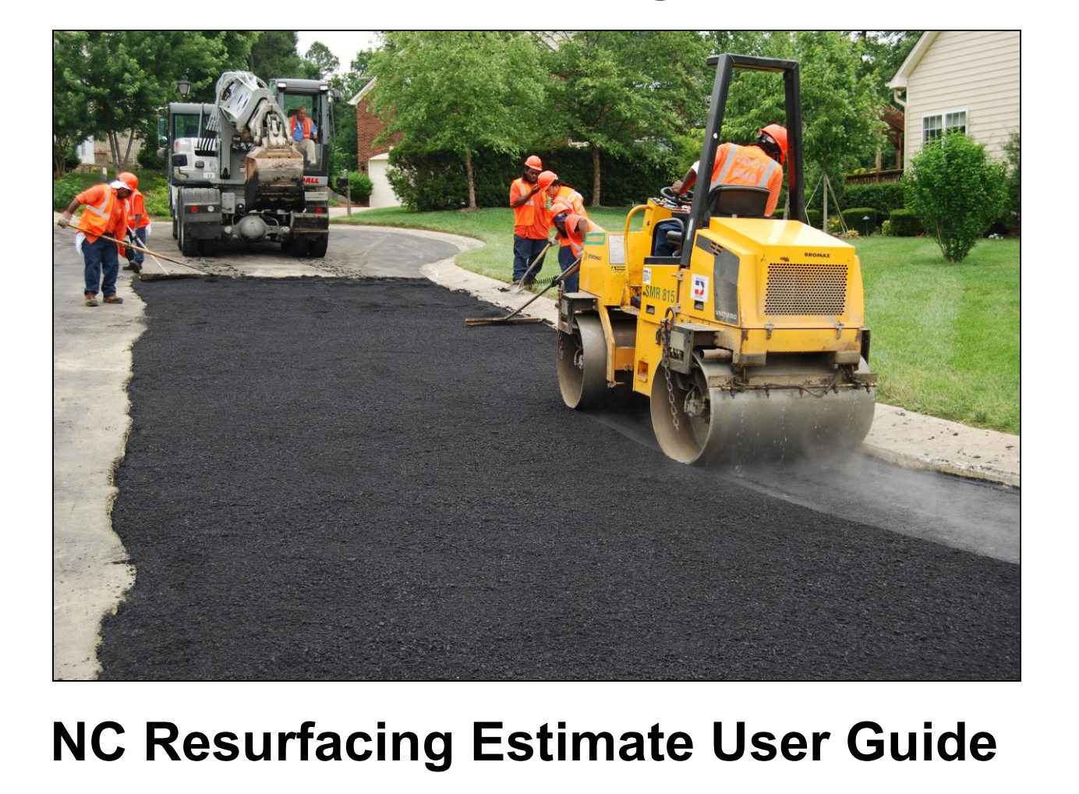
- Follow Installation Instructions on Page 1-2 to download the resurfacing program.
